Alisa Steensen

Module 5.2

1/25/25



# Interview Questions

**I Personal Background:**

**Where and when were you born, and what was your childhood like?**

Born and raised in Council Bluffs, Iowa, I grew up in a large family with 11 siblings, surrounded by animals like chickens, birds, ferrets, goats, cats, and dogs. I was homeschooled my entire life until starting college at 16 to take classes that couldn’t be taught at home.

If I had to sum up my childhood in one word, it would be “grateful.” Growing up in the early 2000s as a homeschooler with such a big family is an experience that only a few could truly understand. We were blessed with endless opportunities, and I see God’s hand in all of it. Looking back, there is nothing I would change. I am deeply thankful for the chance to live the childhood I had.

**Can you tell me about your family? (Parents, siblings, or other significant relationships)**

My parents are both Christians who decided early on to homeschool our family, believing it would provide a higher level of education compared to public or private schools. My dad had the opportunity to work from home early in his career, which meant I got to spend a lot of time with him. Some of my favorite memories with him are playing games, going to football practice, and preparing together for debate tournaments.

My mom was the one who handled almost everything around the house while also teaching us and making sure we were raised to be respectful adults. Some of my earliest memories with her are from doctor appointments or piano practice days, listening to her stories all day long.

Growing up with my siblings was a great experience. We bonded over games and movies, but we were also the kind of family that tried a lot of different things together, always finding joy in the experience.

**Education & Career:**

**What were your favorite subjects or activities in school, and why?**

In school my favorite subject were things revolving around logic like debate or math. I found that these things came easier to me and I was naturally more attracted to them/

**How did you decide on your career path, and what has been the most rewarding part of your work?**

Deciding on a career path was a challenging process for me because my childhood seemed to fly by so quickly. Toward the end of high school, I became really interested in football and dreamed of playing tackle for a college team, with the hope of eventually going professional. At the same time, I was excelling in speech and debate, winning state and even competing at nationals a couple of times. Because of this, I often told people I might pursue a career as a paralegal or lawyer.

Around that time, I also developed a passion for eSports, playing *Call of Duty*. What started as a fun activity with a friend from debate turned into a serious interest after I got a taste of the competitive scene. I even considered pursuing eSports as a career. With so many interests pulling me in different directions, I began college at 16, starting with general education courses because I wasn’t sure what I wanted to do.

After two years of college, I switched to premed with the intention of studying neuroscience. I was fascinated by the brain and how the body works, especially because of my interest in health and fitness. However, while I enjoyed the subject matter, I wasn’t convinced it was the right career path for me. I decided to take a couple of years off from college to figure things out. During that time, I worked easily over 100 hours a majority of weeks between 2 and even 3 jobs. At one point, I considered becoming a supervisor at FedEx Freight and working my way up the ladder there. I was also working as a life coach and direct support professional for individuals with mental health challenges or disabilities.

Despite the heavy workload, I stayed connected to my passions for sports and eSports. I played basketball and joined clubs to compete in games, but after fracturing my ankle, I moved on and got back into eSports. At that time, I was balancing work at FedEx, regular gym sessions, and competing in eSports tournaments.

While living on my own during the COVID era, I got bored one day and downloaded an app that allowed you to FaceTime people from around the world. On that app, I had a conversation with someone who encouraged me to explore AI and computer programming. Initially, it sounded way over my head since I was mostly doing manual labor and gaming. But the idea stuck with me. Later that year, I asked my brother at the gym if I should give programming a try, and his firm “no” was discouraging. However, after my grandmother passed away, I felt a strong conviction that programming was the path for me.

The only issue was that I owed a couple thousand dollars to my previous college from an unpaid semester. Despite this, I visited Iowa Western Community College on the last day of June to talk to a counselor. That visit turned out to be pivotal. I learned about a scholarship that could completely cover my tuition. The catch? I needed to sign up for classes that very same day. I took the leap.

Fast forward to today, I am a Software Engineer at ACI Worldwide Inc. Looking back, the most rewarding part of this journey is seeing how much can change in a short time with the right amount of dedication and perseverance. While my journey isn’t over, it’s incredible to reflect on how far I’ve come.

**Interests & Achievements:**

**What are some hobbies or activities you’ve enjoyed throughout your life?**

Growing up, my favorite hobbies were sports, movies, and video games. After high school, my interests shifted. I lost interest in video games from a casual standpoint and began focusing more on hobbies like Bible study, health, and fitness.

**What accomplishment are you most proud of, and why?**

One of the most significant moments in my life was getting baptized during high school. Jesus not only held my family together but has also been the foundation that keeps me grounded throughout my life. I am fully aware that I am nothing on my own and that any accomplishments I have are solely because of what God has given me. Jesus truly is the one who gives and takes away. With this understanding, I know I would rather have no accomplishments at all than live a life void of Jesus.

**Challenges & Values:**

**Have you faced any significant challenges in life, and how did you overcome them?**

Yes, I’ve struggled with various things in my life, such as fear and doubt. When I was younger, I remember going to my dad’s office for a "take your kid to work" day. At the time, I thought it would be impossible for me to ever work in a place like that, where my dad was working. Those moments of self-doubt stayed with me, but they also helped shape my journey.

**What values or principles guide you in your everyday life?**

My main values and principles are deeply rooted in living a life for Jesus Christ. For me, this means picking up my cross daily and following Him. There are days when I fall short, but through it all, I strive to keep my eyes fixed on the ark and follow wherever it leads me.

**Relationships & Impact:**

**Who has had the most influence on your life, and how?**

Short answer: Jesus Christ. The long answer, though, is my father. My dad is a very respectable individual who isn’t perfect but has always inspired me to strive toward living a Godly life. Growing up, I saw him studying the Word and consistently demonstrating the values of a Christian man.

**What legacy or message would you like to leave for future generations?**

My message would be to learn to enjoy suffering, as it not only produces righteousness but also allows you to grow. The thing about suffering is that it’s something you will have to face eventually, so seeking it out before it finds you is truly the secret.

**Biography of Joshua Kreifels**

Josh Kreifels was born on August 11, 1995, and raised in Council Bluffs, Iowa. He grew up as a part of a large, close-knit family of 11 children. His parents are Joe & Yvonne Kreifels and his siblings are Alisa, Amanda, Joseph, John, Andrea, Jacob, Anna, Justin, Josiah, & Jason. Surrounded by a variety of animals, including chickens, birds, ferrets, goats, gerbils, cats, and dogs, his childhood was filled with adventure. Homeschooled throughout his childhood, he began college at just 16 years of age to pursue classes that couldn’t be taught at home. Reflecting on his upbringing, he describes it as one of gratitude, shaped by faith and the unique experience of growing up in such a unique household. He states, “I am deeply thankful for the chance to live the childhood I had.”

His parents, both devout Christians, instilled strong values and a love for learning in their children. His father, a dedicated professional Software Engineer, who worked from home, created many fond memories. From football practices to preparing for debate tournaments. His mother, the heart of their home, managed daily life and ensured the children were raised to be respectful and hardworking. She states, “Josh growing up, was good boy, who was intelligent, respectful, and full of life.” He recalls fond memories with his mother while running errands or piano practice, listening to her stories of life and discussing her faith. His siblings became lifelong companions, bonding over video games, movies, and shared adventures.

Academically, Josh gravitated toward logical subjects like math and debate, excelling in competitions and earning opportunities to compete at the state and national levels. While he dreamed of playing college football professionally or pursuing a career in law, his interests shifted as he explored a career in eSports, Call of Duty competitions, and later, neuroscience in his premed studies. Josh was fascinated by the brain and how the body worked. However, as he began that journey, he soon realized it was not the right career path for him.

The journey to his current career as a Software Engineer at ACI Worldwide was far from straightforward. Josh reflects on his childhood when his father took him to “take your kid to work” day and remembers feeling doubt that it would be something he could pursue. After taking a break from college to work multiple jobs, which included FedEx, and life coaching for the mentally disabled, he rediscovered his passion for learning and technology during the pandemic. Encouraged by a conversation with a stranger, he decided to explore programming, overcoming initial doubts and financial hurdles to enroll in Iowa Western Community College. A pivotal scholarship opportunity allowed him to embark on this path, leading to a rewarding career in software development. As Josh continued this journey, he is grateful that he pushed through the self-doubt.

Beyond his career, Josh has always maintained a strong connection to his faith and values. Being baptized in high school was a defining moment in his life, solidifying his belief that all his accomplishments are rooted in God’s grace. In addition to these pursuits, Josh has always enjoyed trying new activities. From hiking. Kayaking, Marathons, Krav Maga, and Jui Jitsu, to experimenting with different recipes in the kitchen, he embraces any opportunity to learn and tackle new challenges. Over the years, he has also taken an interest in mentoring others, sharing his life experiences to inspire and guide them in their own journeys.

Despite challenges with fear and doubt, he has embraced the lessons learned from those struggles, finding strength in Christ and inspiration from his father’s example. He states, “growing up I saw my father consistently studying the word and demonstrating the values of a Christian man.” Josh, guided by his faith, strives to live a life of purpose and resilience, picking up his cross daily and following where it leads.

His message to future generations is both profound and practical: “Learn to enjoy suffering, as it not only produces righteousness but also allows you to grow. Suffering is inevitable, so seeking it out before it finds you is truly the secret.” Through his life’s journey, Josh exemplifies the power of faith, perseverance, and a willingness to embrace challenges head-on.

# Images:

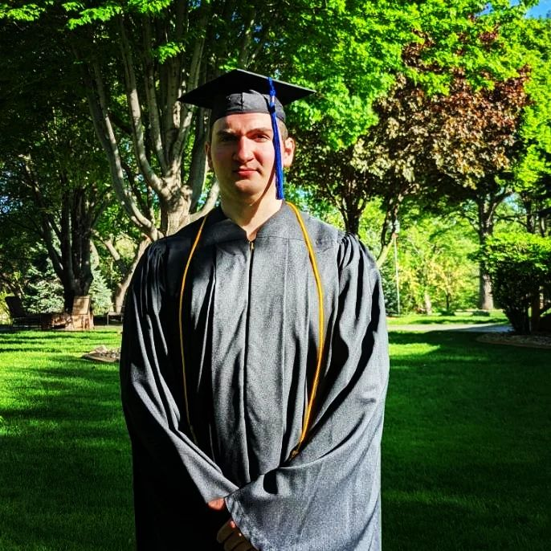 Joshua graduated from homeschool in May of 2024 and graduated from Iowa Western Community College in May of 2023 with a degree in Computer Science.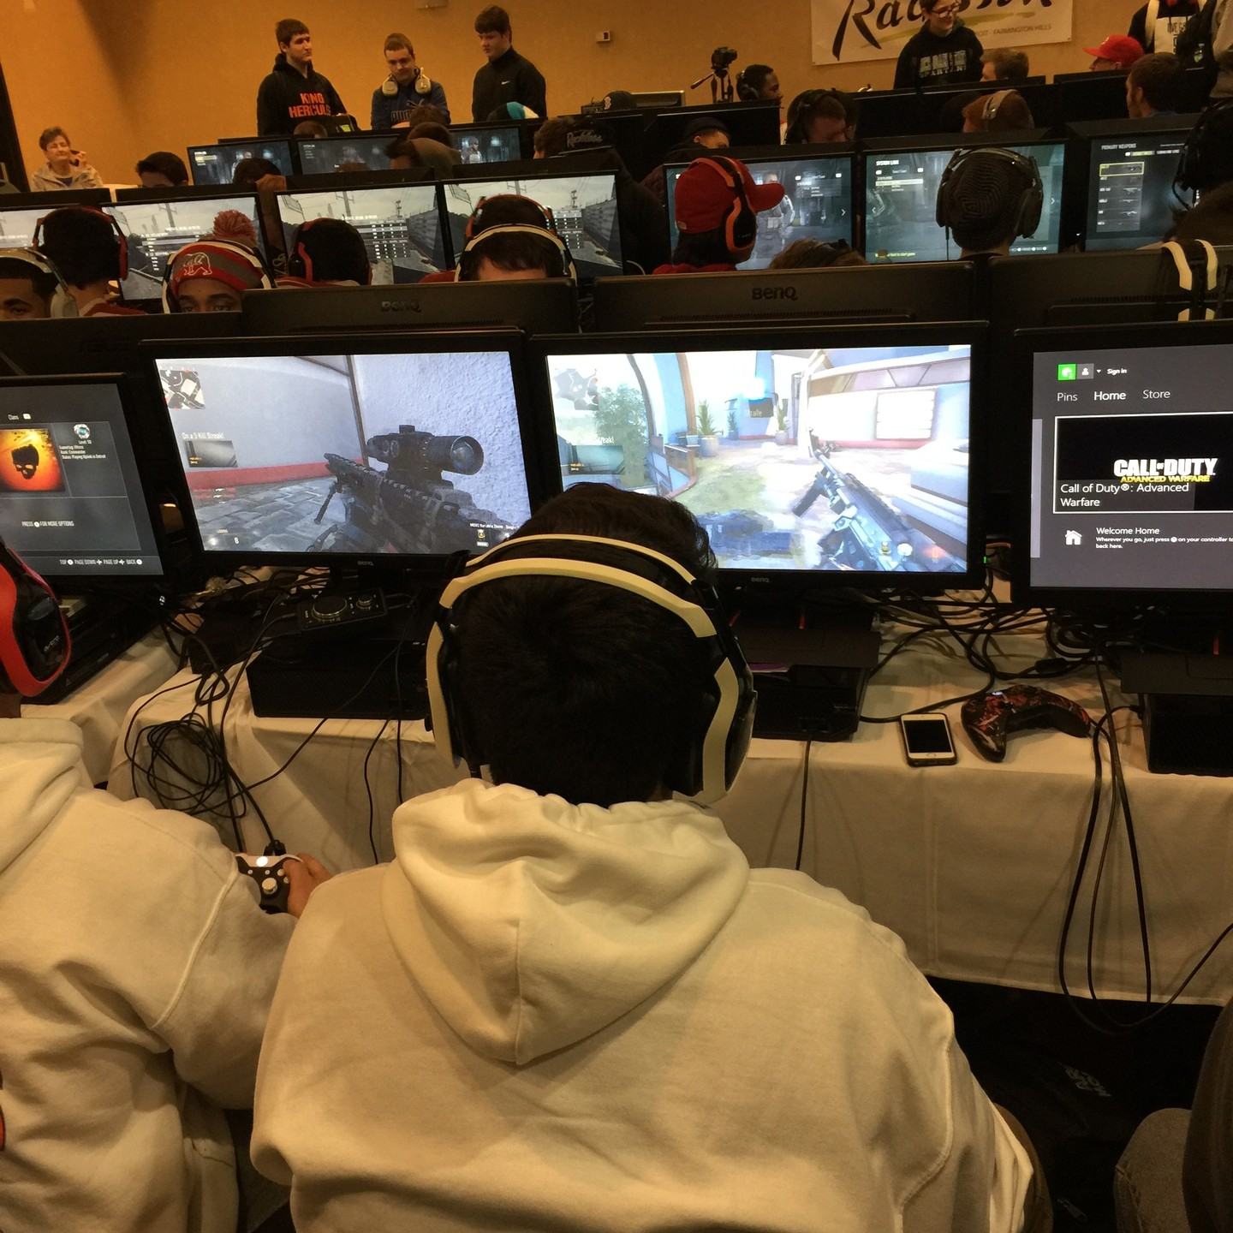 Joshua has competed in numerous video game tournaments around the country, demonstrating his skill, strategic thinking, and passion for gaming on a competitive level.

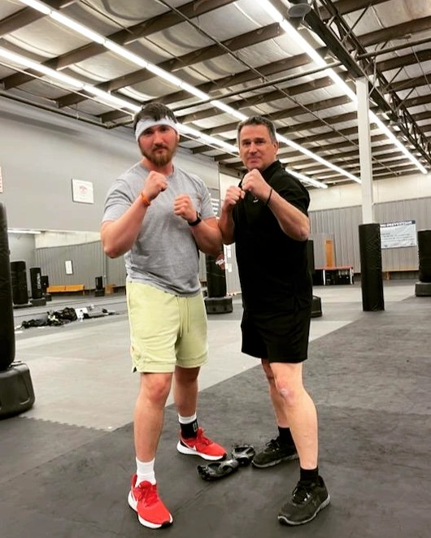 Josh keeps himself busy with Krav Maga and Jiu-Jitsu, which he enjoys not only as a way to stay physically fit but also as a method to build endurance and mental toughness. For him, it's more than just a workout—it's a practice that sharpens both body and mind.

For more information on Brazilian Jui Jitsu and Krav Maga, click here. https://sgskravmaga.com.au/krav-maga-vs-bjj/#:~:text=The%20main%20difference%20between%20Brazilian,Both%20have%20their%20benefits.

 Josh has competed in various tournaments for Krav Maga and Jiu-Jitsu, showcasing his dedication to martial arts and physical discipline. His hard work and commitment to improving his skills paid off, as he proudly earned both 1st and 2nd place titles in different competitions. These achievements reflect not only his technical ability but also his determination, resilience, and passion for the sport.

 Josh enjoys going to the shooting range, where he practices his marksmanship and finds it both a challenging and relaxing way to focus and improve his skills.

 Josh spends many hours bodybuilding and strength training, pushing himself to achieve new personal goals and enjoying the process of building mental discipline.

 About photo

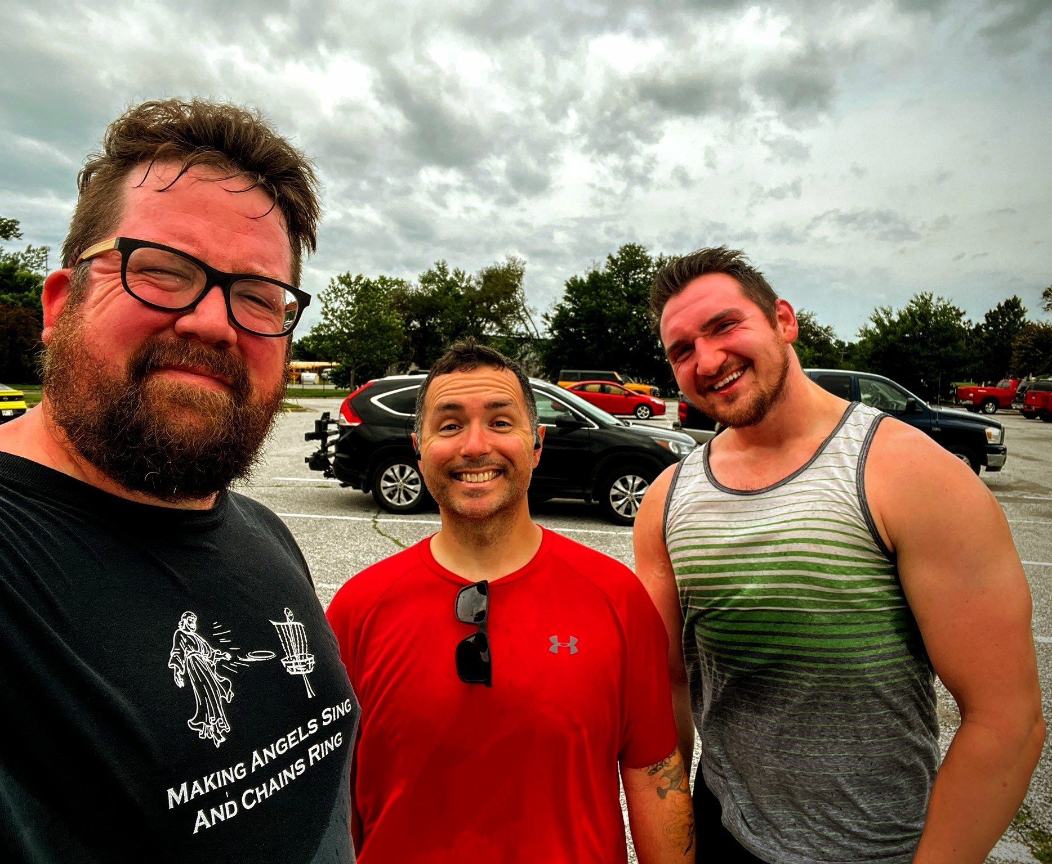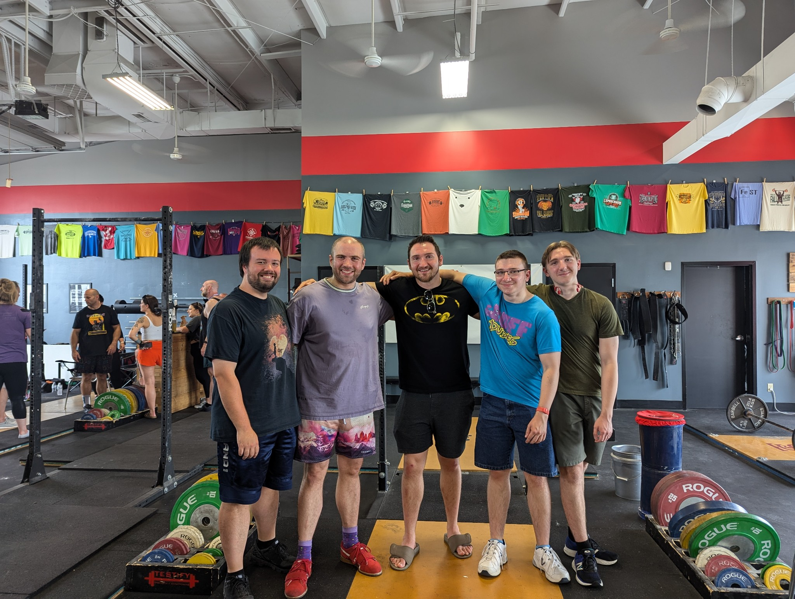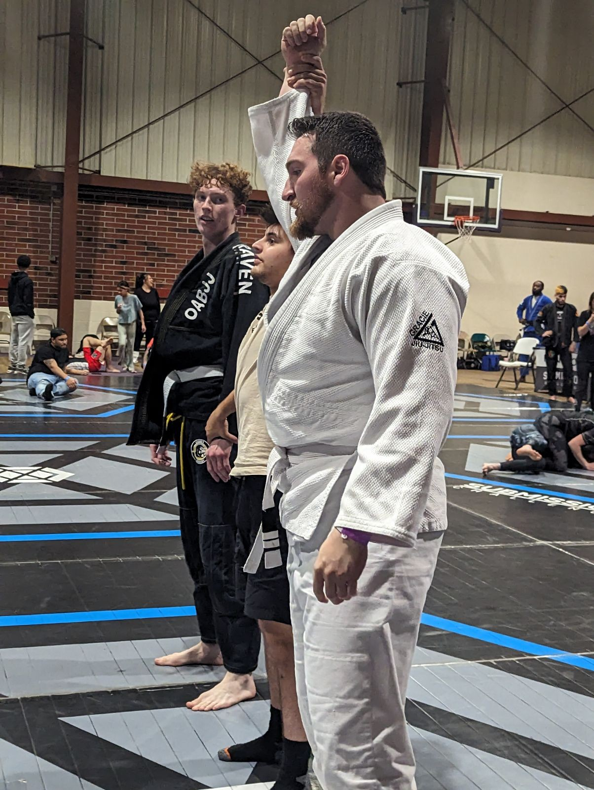

# WireFrames

